Exercise 7: Packages

- TABLE CREATION AND POPULATING WITH DUMMY DATA:
CREATE TABLE Customers (
CustomerID NUMBER PRIMARY KEY,
Name VARCHAR2(100),
DOB DATE,
Balance NUMBER(12,2),
LastModified DATE
);

CREATE TABLE Accounts (
AccountID NUMBER PRIMARY KEY,
CustomerID NUMBER,
AccountType VARCHAR2(20),
Balance NUMBER(12,2),
LastModified DATE,
CONSTRAINT fk_account_customer
FOREIGN KEY (CustomerID)
REFERENCES Customers(CustomerID)
);

CREATE TABLE Transactions (
TransactionID NUMBER PRIMARY KEY,
AccountID NUMBER,
TransactionDate DATE,
Amount NUMBER(12,2),
TransactionType VARCHAR2(20),
CONSTRAINT fk_transaction_account
FOREIGN KEY (AccountID)
REFERENCES Accounts(AccountID)
);

CREATE TABLE Loans (
LoanID NUMBER PRIMARY KEY,
CustomerID NUMBER,
LoanAmount NUMBER(12,2),
InterestRate NUMBER(5,2),
StartDate DATE,
EndDate DATE,
CONSTRAINT fk_loan_customer
FOREIGN KEY (CustomerID)
REFERENCES Customers(CustomerID)
);

CREATE TABLE Employees (
EmployeeID NUMBER PRIMARY KEY,
Name VARCHAR2(100),
Position VARCHAR2(50),
Salary NUMBER(12,2),
Department VARCHAR2(50),
HireDat
INSERT INTO Customers (CustomerID, Name, DOB, Balance, LastModified)
VALUES (1, 'John Doe', TO_DATE('1985-05-15', 'YYYY-MM-DD'), 1000, SYSDATE);

INSERT INTO Customers (CustomerID, Name, DOB, Balance, LastModified)
VALUES (2, 'Jane Smith', TO_DATE('1990-07-20', 'YYYY-MM-DD'), 1500, SYSDATE);

INSERT INTO Accounts (AccountID, CustomerID, AccountType, Balance, LastModified)
VALUES (1, 1, 'Savings', 1000, SYSDATE);

INSERT INTO Accounts (AccountID, CustomerID, AccountType, Balance, LastModified)
VALUES (2, 2, 'Checking', 1500, SYSDATE);

INSERT INTO Transactions (TransactionID, AccountID, TransactionDate, Amount, TransactionType)
VALUES (1, 1, SYSDATE, 200, 'Deposit');

INSERT INTO Transactions (TransactionID, AccountID, TransactionDate, Amount, TransactionType)
VALUES (2, 2, SYSDATE, 300, 'Withdrawal');

INSERT INTO Loans (LoanID, CustomerID, LoanAmount, InterestRate, StartDate, EndDate)
VALUES (1, 1, 5000, 5, SYSDATE, ADD_MONTHS(SYSDATE, 60));

INSERT INTO Employees (EmployeeID, Name, Position, Salary, Department, HireDate)
VALUES (1, 'Alice Johnson', 'Manager', 70000, 'HR',
TO_DATE('2015-06-15', 'YYYY-MM-DD'));

INSERT INTO Employees (EmployeeID, Name, Position, Salary, Department, HireDate)
VALUES (2, 'Bob Brown', 'Developer', 60000, 'IT',
TO_DATE('2017-03-20', 'YYYY-MM-DD'));

COMMIT;

- SOLVING SCENARIO 1:
Scenario 1: Group all customer-related procedures and functions into a package.
  - Question: Create a package CustomerManagement with procedures for adding a new customer, updating customer details, and a function to get customer balance.
Package Specification:
CREATE OR REPLACE PACKAGE CustomerManagement AS

PROCEDURE AddCustomer(
p_id NUMBER,
p_name VARCHAR2,
p_dob DATE,
p_balance NUMBER
);

PROCEDURE UpdateCustomer(
p_id NUMBER,
p_balance NUMBER
);

FUNCTION GetCustomerBalance(
p_id NUMBER
) RETURN NUMBER;

END CustomerManagement;
/
Package Body:
CREATE OR REPLACE PACKAGE BODY CustomerManagement AS

PROCEDURE AddCustomer(
p_id NUMBER,
p_name VARCHAR2,
p_dob DATE,
p_balance NUMBER
)
IS
BEGIN
INSERT INTO Customers
VALUES(
p_id,
p_name,
p_dob,
p_balance,
SYSDATE
);

DBMS_OUTPUT.PUT_LINE('Customer Added Successfully');
END;

PROCEDURE UpdateCustomer(
p_id NUMBER,
p_balance NUMBER
)
IS
BEGIN
UPDATE Customers
SET Balance = p_balance,
LastModified = SYSDATE
WHERE CustomerID = p_id;

DBMS_OUTPUT.PUT_LINE('Customer Updated Successfully');
END;

FUNCTION GetCustomerBalance(
p_id NUMBER
)
RETURN NUMBER
IS
v_balance NUMBER;
BEGIN
SELECT Balance
INTO v_balance
FROM Customers
WHERE CustomerID = p_id;

RETURN v_balance;
END;

END CustomerManagement;
/
Test:
SET SERVEROUTPUT ON;

EXEC CustomerManagement.AddCustomer(3,'Bob Jim',TO_DATE('1997-01-10','YYYY-MM-DD'),3000);

EXEC CustomerManagement.UpdateCustomer(1,5000);

DECLARE
v_balance NUMBER;
BEGIN
v_balance := CustomerManagement.GetCustomerBalance(1);

DBMS_OUTPUT.PUT_LINE(
'Balance = ' || v_balance
);
END;
/
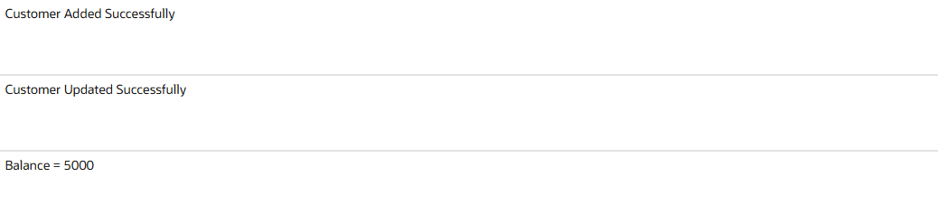
Updated table:
SELECT * FROM Customers;

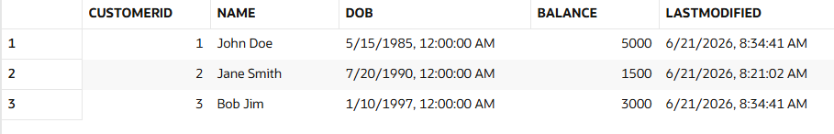

- SOLVING SCENARIO 2:
Scenario 2: Create a package to manage employee data.
  - Question: Write a package EmployeeManagement with procedures to hire new employees, update employee details, and a function to calculate annual salary.
Package Specification:
CREATE OR REPLACE PACKAGE EmployeeManagement AS

PROCEDURE HireEmployee(
p_id NUMBER,
p_name VARCHAR2,
p_position VARCHAR2,
p_salary NUMBER,
p_department VARCHAR2
);

PROCEDURE UpdateEmployee(
p_id NUMBER,
p_salary NUMBER
);

FUNCTION CalculateAnnualSalary(
p_id NUMBER
) RETURN NUMBER;

END EmployeeManagement;
/

Package Body:
CREATE OR REPLACE PACKAGE BODY EmployeeManagement AS

PROCEDURE HireEmployee(
p_id NUMBER,
p_name VARCHAR2,
p_position VARCHAR2,
p_salary NUMBER,
p_department VARCHAR2
)
IS
BEGIN
INSERT INTO Employees
VALUES(
p_id,
p_name,
p_position,
p_salary,
p_department,
SYSDATE
);

DBMS_OUTPUT.PUT_LINE('Employee Hired Successfully');
END;

PROCEDURE UpdateEmployee(
p_id NUMBER,
p_salary NUMBER
)
IS
BEGIN
UPDATE Employees
SET Salary = p_salary
WHERE EmployeeID = p_id;

DBMS_OUTPUT.PUT_LINE('Employee Updated Successfully');
END;

FUNCTION CalculateAnnualSalary(
p_id NUMBER
)
RETURN NUMBER
IS
v_salary NUMBER;
BEGIN
SELECT Salary
INTO v_salary
FROM Employees
WHERE EmployeeID = p_id;

RETURN v_salary * 12;
END;

END EmployeeManagement;
/

Test:
SET SERVEROUTPUT ON;

EXEC EmployeeManagement.HireEmployee(3,'Kim Park','Analyst',55000,'Finance');

EXEC EmployeeManagement.UpdateEmployee(2,65000);

DECLARE
v_annual NUMBER;
BEGIN
v_annual :=
EmployeeManagement.CalculateAnnualSalary(2);

DBMS_OUTPUT.PUT_LINE(
'Annual Salary = ' || v_annual
);
END;
/

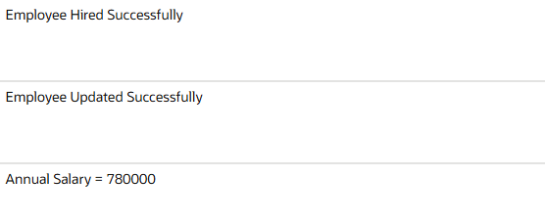

Updated table:
SELECT * FROM Employees;
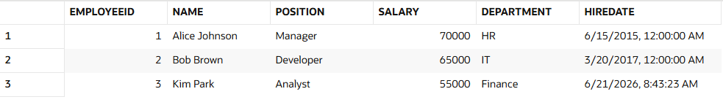
- SOLVING SCENARIO 3:
Scenario 3: Group all account-related operations into a package.
  - Question: Create a package AccountOperations with procedures for opening a new account, closing an account, and a function to get the total balance of a customer across all accounts.
Package Specification:
CREATE OR REPLACE PACKAGE AccountOperations AS

PROCEDURE OpenAccount(
p_accid NUMBER,
p_custid NUMBER,
p_type VARCHAR2,
p_balance NUMBER
);

PROCEDURE CloseAccount(
p_accid NUMBER
);

FUNCTION GetTotalBalance(
p_custid NUMBER
) RETURN NUMBER;

END AccountOperations;
/

Package Body:
CREATE OR REPLACE PACKAGE BODY AccountOperations AS

PROCEDURE OpenAccount(
p_accid NUMBER,
p_custid NUMBER,
p_type VARCHAR2,
p_balance NUMBER
)
IS
BEGIN
INSERT INTO Accounts
VALUES(
p_accid,
p_custid,
p_type,
p_balance,
SYSDATE
);

DBMS_OUTPUT.PUT_LINE(
'Account Opened Successfully'
);
END;

PROCEDURE CloseAccount(
p_accid NUMBER
)
IS
BEGIN
DELETE FROM Accounts
WHERE AccountID = p_accid;

DBMS_OUTPUT.PUT_LINE(
'Account Closed Successfully'
);
END;

FUNCTION GetTotalBalance(
p_custid NUMBER
)
RETURN NUMBER
IS
v_total NUMBER;
BEGIN
SELECT SUM(Balance)
INTO v_total
FROM Accounts
WHERE CustomerID = p_custid;

RETURN NVL(v_total,0);
END;

END AccountOperations;
/

Test:
SET SERVEROUTPUT ON;

EXEC AccountOperations.OpenAccount(3,2,'Savings',4000);

DECLARE
v_total NUMBER;
BEGIN
v_total :=
AccountOperations.GetTotalBalance(1);

DBMS_OUTPUT.PUT_LINE(
'Total Balance = ' || v_total
);
END;
/

EXEC AccountOperations.CloseAccount(3);

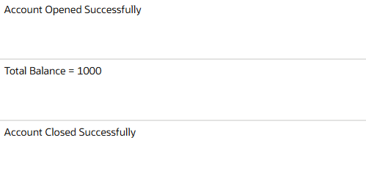
Updated table:
SELECT * FROM Accounts;

